**Introduction/Business Problem**

**Bangkok** is the capital city of Thailand and also the most crowd city in the country. From 2010 census conducted by the **National Statistic Office of Thailand**[1], the population in the city was over **8** millions. In 2019, it is estimated to home over **10** millions people making it 32th in the most populated city ranking, just a single place behind its neighbor **Ho Chi Minh City** in **Vietname** [2].

Even though the city is home to over **13%** of the country's total population, it is also an important international business areas as well as it privides facilities to more than 120,000 asian people and notably over 50,000 western people. Bangkok is considered a **primate city**, or one that serves as the population, political and financial center of a country with no other rival city[3].

It is clear that we can find great diversity in terms of businesses, people, and places in this city; however, are those diverse categories mingling together equally in all areas perfectly rendering the city into an ideal mixture or are there still several segments that we can tell apart? Do all areas in Bangkok play equal roles in term of businesses or living places? **Knowing that there are a lot of opportunities to be discovered in this well-populated place, to be able to clearly identifying where we should start some certain businesses will be a great idea and this is the problem that we are going to solve here.**

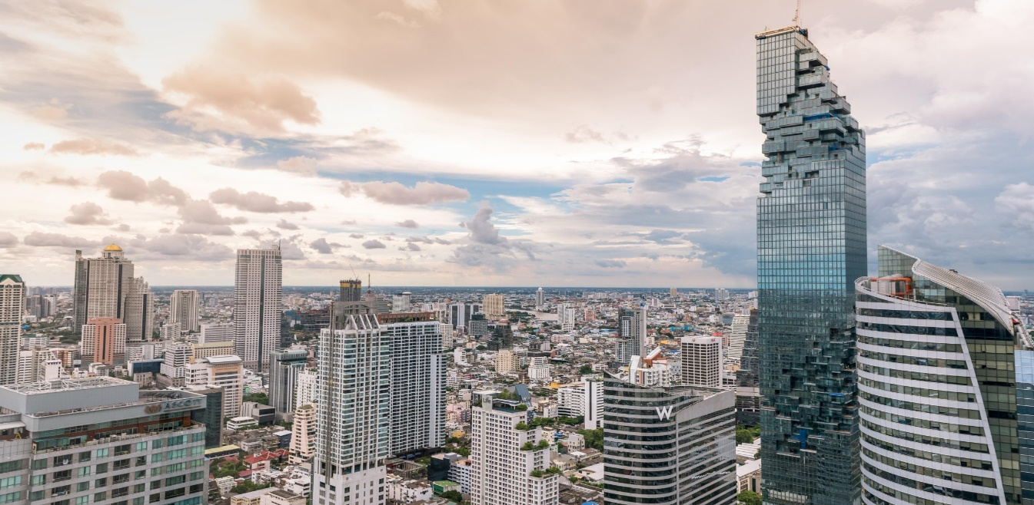

**References**:

[1] National Statistic Office of Thailand (<http://web.nso.go.th/>)

[2] Capital City Population Ranking (<http://www.citymayors.com/statistics/largest-cities-population-125.html>)

[3] Bangkok as the Major City of Thailand (<http://worldpopulationreview.com/world-cities/bangkok-population/>)